NA-DVR32224
32 CHANNEL PC-BASED DVR
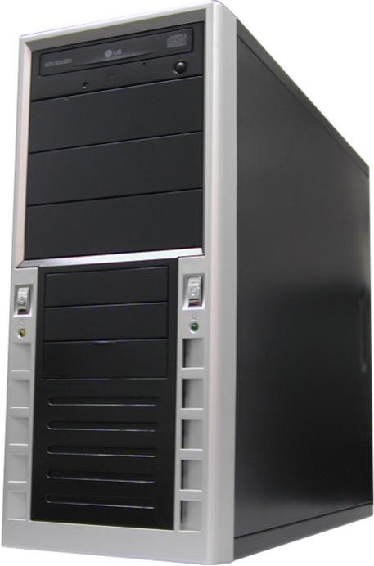
- 240 fps display & Recording
- 16 audio inputs
- Remote viewing over internet
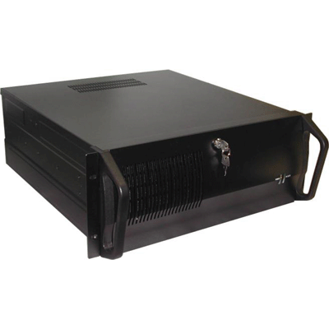
- Composite 2nd monitor output

Display FPS | 240
Record FPS | 240 (at 1CIF)
Video Channels | 32 BNC-M
Audio Channels | 16 RCA-F
Record Resolution | 1CIF: 352x240, 2CIF: 704x240, 4CIF: 704x480
Compression | Proprietary Enhanced MJPEG (2~7kb/ frame at 1CIF)
Video Input Voltage | 1 Vpp CVBS
Video Input Impedance | 75 Ohms (hi-impedance x 16 switchable)
Video Recording Format | analog line-in, 11 KHz sampling rate
Monitor Output | 1 x VGA DB9, 1280x1024, 32 Bit, 70 Hz
Spot Monitor Output | 1 x BNC-M, 32 split only, no switching
USB Output | 2 x front, 2 x rear
RS232 | 1 x DB9-M (RS232/485 converter required for PTZ)
Network | 1 x 10/100 NIC onboard
Audio Out | 1 x Speaker Out
Media Writer | 1 x CDRW Drive
* Above specification and design subject to change without notification

