NA-DVR16224
16 CHANNEL PC-BASED DVR
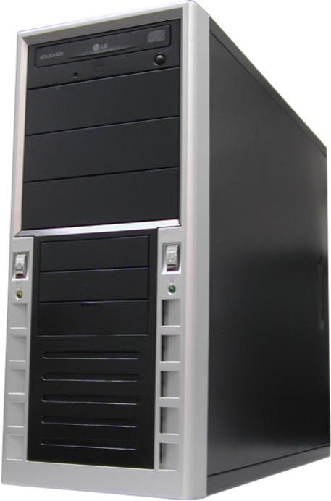
- 120 fps display & Recording
- 4 audio inputs
- Remote viewing over internet
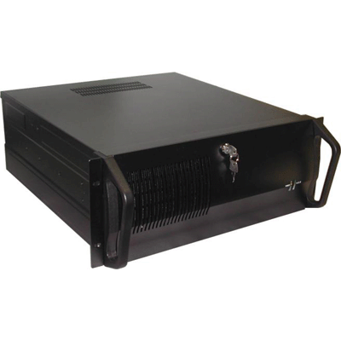
- Composite 2nd monitor output
- MPEG4 Compression

Camera Input | 16 Channels
Display /Recording Speed | 120 fps / 120 fps
Video Partition | 1, 4, 7, 9, 16 Splits
Monitor Output | RGB(VGA), Composite
Video Resolution | 640x480,640x240,320x240
Quality Control | 5 Level of Controlling
Image Size | 2~4KB(320X240, Medium)
Video Compression | MPEG4
Screen Switching | 1-10 Seconds
Output Resolution | Over 400 TV lines(1 screen)
Playback Display | Multiple camera views on the screen simultaneously
Network | LAN, Cable Modem, ISDN,PTSN,PPP(dialup)
Alarm Output Time | 1 second - unlimited time selection
Motion Selection | 5 types of sensors
Power Tolerance | Supported
Auto Detection | Supported
Data Back Up | CDRW, Ethernet, HDD
Audio Input | 4 Channels
Audio Compression | MPEG4
Remote Control | RS232(PAN/Tilt/Zoom/IRIS)
* Above specification and design subject to change without notification

