NA-DVR08224
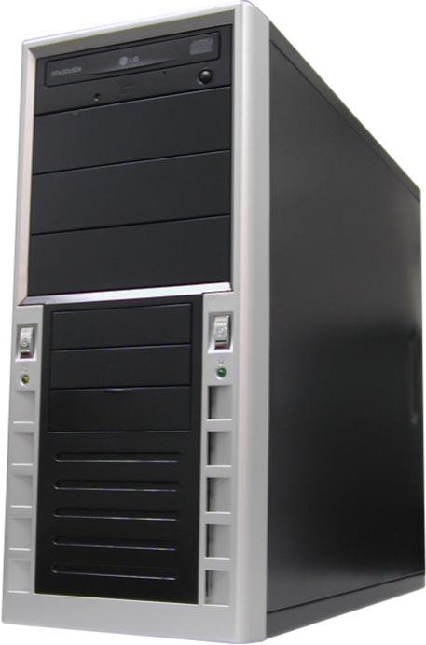
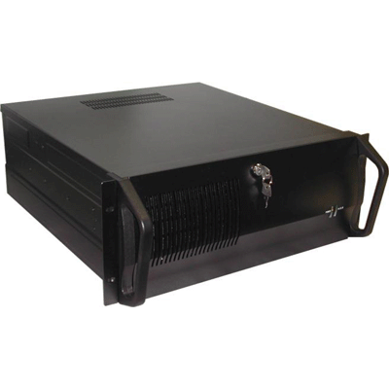
8 CHANNEL PC-BASED DVR
- 240 fps display & Recording
- Remote viewing over internet
- Engine-K compression (1~3kb/image

Camera Input | 8 Channels
Display /Recording Speed | 240 fps / 240 fps
Video Partition | 1, 4, 6, 9 splits
Monitor Output | VGA only
Image Size | Average 1~3KB/image (320 x 240)
Video Compression | Engine-K
Screen Switching | 1-10 Seconds
Output Resolution | Over 400 TV lines(1 screen)
Playback Display | Multiple camera views on the screen simultaneously
Network | LAN, Cable Modem, ISDN,PTSN,PPP(dialup)
Image Verification | Watermark
Motion Selection | 5 types of sensors
Power Tolerance | Supported
Auto Detection | Supported
Data Back Up | CDRW, Ethernet, HDD
Audio Input | None

*Above specification and design subject to change without notification

