NA-DVR04224
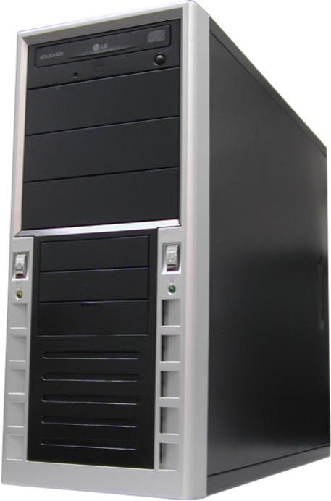
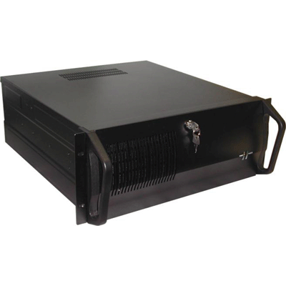
4 CHANNEL PC-BASED DVR
- 30 fps display & Recording
- 1 audio input
- Remote viewing over internet
- Composite video output
- MPEG4 compression

Camera Input | 4 Channels
Display /Recording Speed | 30 fps / 30 fps
Video Partition | 1, 4 Splits
Monitor Output | RGB(VGA), Composite
Video Resolution | 640x480,640x240,320x240
Quality Control | 5 Level of Controlling
Image Size | 2~4KB(320X240, Medium)
Video Compression | MPEG4
Screen Switching | 1-10 Seconds
Output Resolution | Over 400 TV lines(1 screen)
Playback Display | Multiple camera views on the screen simultaneously
Network | LAN, Cable Modem, ISDN,PTSN,PPP(dialup)
Alarm Output Time | 1 second - unlimited time selection
Motion Selection | 5 types of sensors
Power Tolerance | Supported
Auto Detection | Supported
Data Back Up | CDRW, Ethernet, HDD
Audio Input | 1 Channels
Audio Compression | MPEG4
Remote Control | RS232(PAN/Tilt/Zoom/IRIS)

*Above specification and design subject to change without notification

